**Lab Exercise 1- Working with Git Revert**

**Lab Exercise: Git Revert**

This exercise will guide you through reverting changes in Git. The git revert command is used to create a new commit that undoes the changes introduced by a previous commit without modifying the history.

**Objective**

* Learn how to use git revert to undo changes from specific commits.
* Practice handling merge conflicts during a revert.

**Prerequisites**

1. Install Git on your system.
2. Set up a Git repository:

git init git-revert-lab

cd git-revert-lab

**Steps**

**1. Set Up the Repository**

1. Create a file:

echo "Line 1" > file.txt

Stage and commit the file:

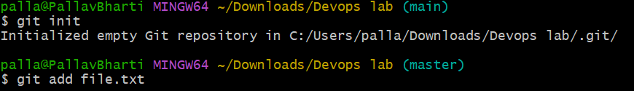

2.Add more changes:

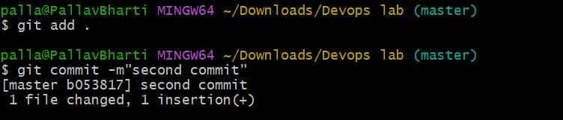

3.Add another change:

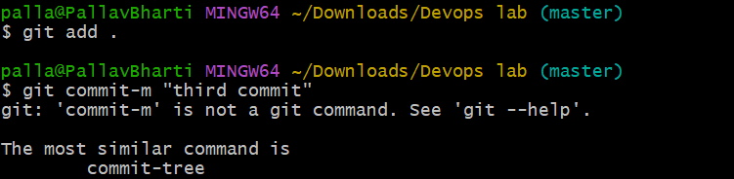4.Verify the commit history:

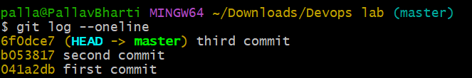

**2. Revert the Last Commit**

1. Revert the most recent commit:

git revert HEAD

1. Git will open a text editor for the commit message. Save and close the editor to complete the revert.
2. Verify the contents of file.txt:

cat file.txt

Output:

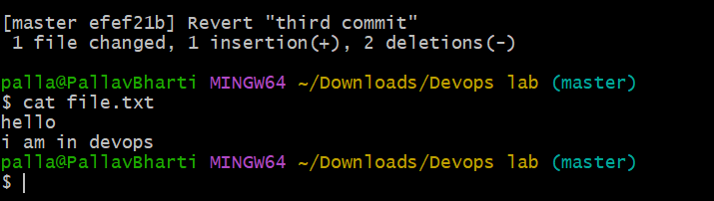

1. Check the commit history:

git log --oneline

output:

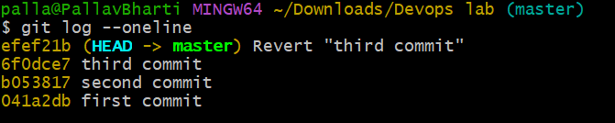

**3. Handle Merge Conflicts During Revert**

1. Modify file.txt:

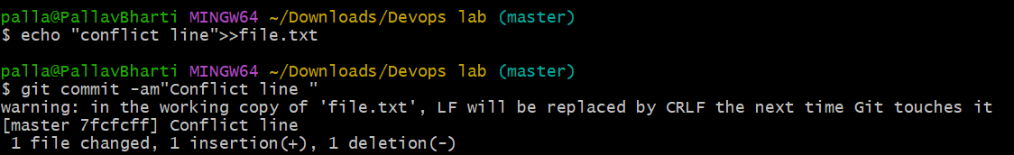

1. Revert the second commit (8b2a1c1 again) to trigger a conflict:

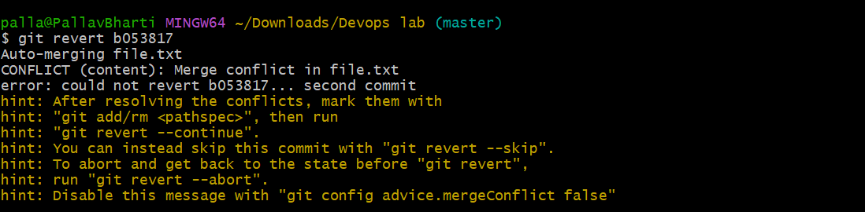

3.Git will indicate a conflict. Resolve it:

* + Open file.txt and remove conflict markers.
  + Keep the desired lines.

1. Stage the resolved file:

git add file.txt

1. Complete the revert:

git revert –continue

